 

Estrutura da placa RFFE_v1 – LNLS:

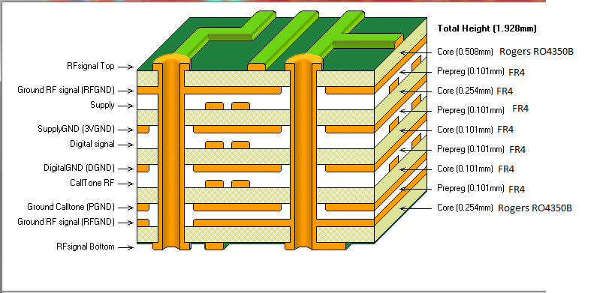

*PCB material:

- Top layer: Rogers RO4350B thickness: 0.020" (0.508mm)

- Bottom Layer: Rogers RO4350B thickness: 0.010" (0.254mm)

- Middle Layers: FR4 thickness: 0.0040" and 0.010" (0.101mm and 0.254)

- Pre-preg: FR4 thickness: 0.0040" (0.101mm)

*Copper thickness:

-Top and bottom layers: 1/2 oz

-Internal layers: 1 oz

*Finish: ENIG (Electroless Nickel/Immersion Gold) *Finished board Thickness: 1.93 mm

Rafael Antonio Baron

Beam Diagnostics Group (DIG)

Brazilian Synchrotron Light Laboratory (LNLS/CNPEM) Campinas - Brazil - P.O.Box 6192 - ZIP Code 13083-970

Tel: +55 19 3517-5069 /// Cel phone: +55 19 8222-3153

Fax: +55 19 3512-1004

05 de junho 2013